**EXPERIMENT NO.: 7**

**NAME OF EXPERIMENT:** Install Tableau, Understand User Interface, Dimensions, Measures, Pages, Filters, Marks and Show Me, Dataset Connections and create visualization.

**Name –Swayam Terode**  **Roll No.: C70 Division : C**

**Date of Performance:** ______________ **Sign of Teacher:**

**AIM:** Install Tableau, Understand User Interface, Dimensions, Measures, Pages, Filters, Marks and Show Me, Dataset Connections and create visualization

### Theory:

### 1 What do you need to know before using Tableau?

You don’t need to know much to use Tableau, but still, a basic awareness of all the types of graphs such as bar graph, line charts, histograms, etc. is preferred.

Along with that, it will be beneficial if you possessed some basic understanding of database management (data types, joins, drill down, drill up, etc.) too.

### 2. Installation:

To work on Tableau, you **need** Tableau, right?

Out of the five above mentioned products, Tableau Desktop, Public and Online offer Data Visual Creation.

**Tableau Desktop**

It is available in the following three formats:

1. [Free trial for 14 days](https://www.tableau.com/products/trial)
2. If you are a student or a teacher, you get free access to the [Desktop](https://www.tableau.com/academic) for a full year.
3. [Purchase Tableau](https://buy.tableau.com/)
4. **Tableau Public**
5. [Tableau Public](https://public.tableau.com/s/download) is purely free of all costs and does not require any license. But it comes with a limitation that all of your data and workbooks are made public to all Tableau users.
6. **Tableau Online**
7. [Tableau Online](https://sso.online.tableau.com/public/idp/SSO) is the best option for you, if you wish to make your Workbooks on the Cloud and be able to access them from anywhere.

## 3. Getting Started

Now that you have the suitable product installed and set up,

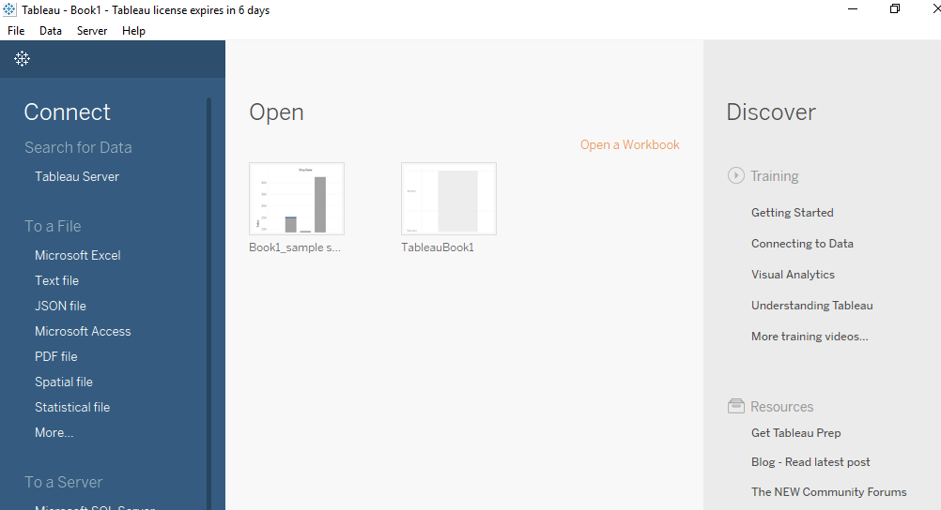

The first thing that you will obviously need to do is import the data onto Tableau. So quickly follow the below steps:

1. Since the data is in an Excel File, click on **Excel** and choose the Sample – Superstore.xls file to get :
2. You can see three sheets on the screen, but we are only going to be dealing with Orders here, so go ahead and drag the same on Drag sheets here :

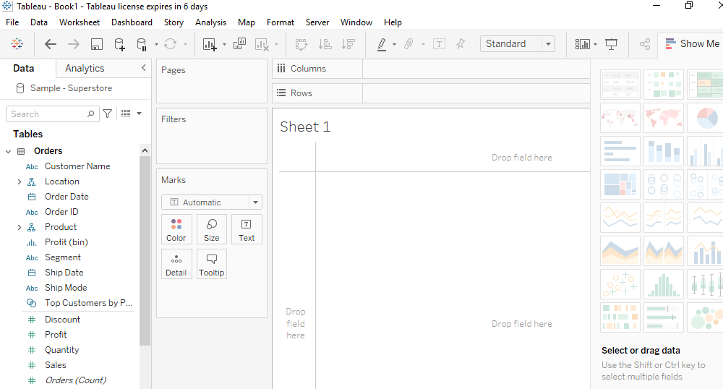

After drag and drop fields to columns and row you can view data in different modes.